Davis Community Learning Center Volunteer Application 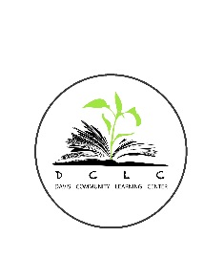
210 E. Center Street
Clearfield, UT 84015
801-402-8395
Name:
Volunteer Position that you are applying for:

Contact information (address, phone numbers, e-mail):

Emergency Contact information; relationship to you, their address and phone number:

Previous work or volunteer experience:

Highest education level reached:

Language(s) spoken:

Physical Limitations:

Other organizations where applicant has volunteered:

Describe your training or experience that may be pertinent to the volunteer position desired:

One or more personal references with contact information:

Please check the skills that you have as they pertain to the volunteer position that you are seeking

- Computer (describe your skill level)
- Tutoring
- Clerical
- Phone calling
- Teaching
- Mentoring

Other skills, talents and interests that you might like to share:

What is your reason for wanting to volunteer with us?

Hours and days available for volunteer work:

How did you hear about us?

Signature Date

______________________________________ _______________________

